ARCHITHA OJHA
2303A52170
BATCH 41

Task 1: Privacy and Data Security in AI-Generated Code
Scenario
AI tools can sometimes generate insecure authentication logic.
Task Description
Use an AI tool to generate a simple login system in Python.
Analyze the generated code to check:
- Whether credentials are hardcoded
- Whether passwords are stored or compared in plain text
- Whether insecure logic is used
Then, revise the code to improve security (e.g., avoid hardcoding, use input validation).
Expected Output
- AI-generated login code
- Identification of security risks
- Revised secure version of the code
- Brief explanation of improvements

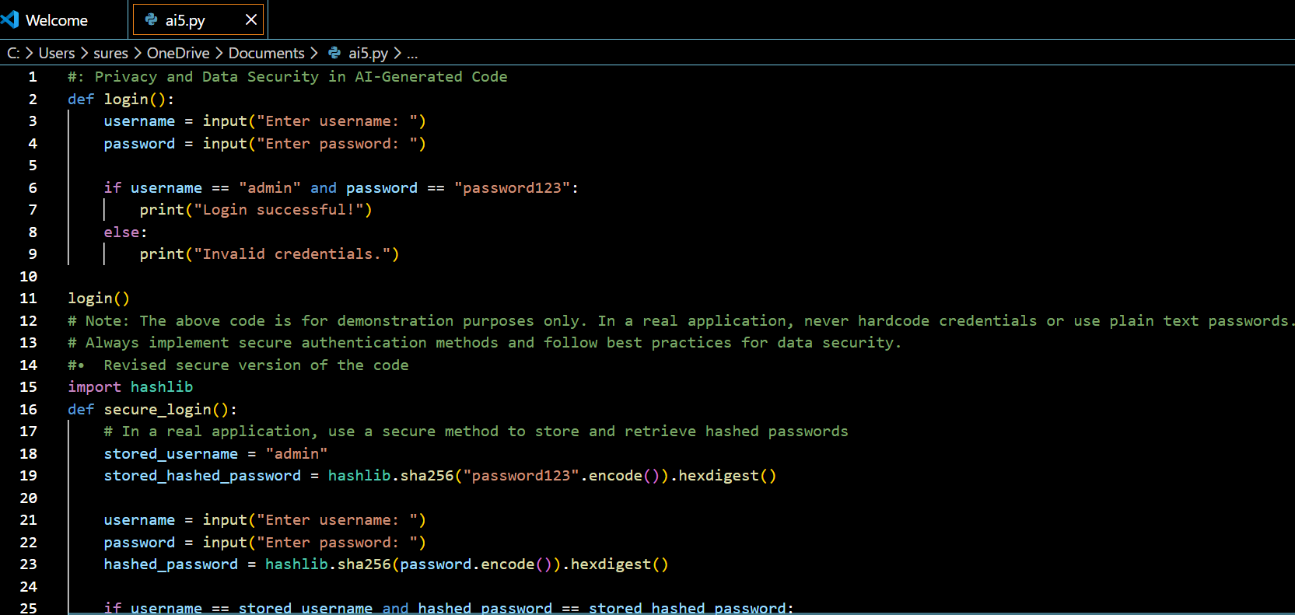

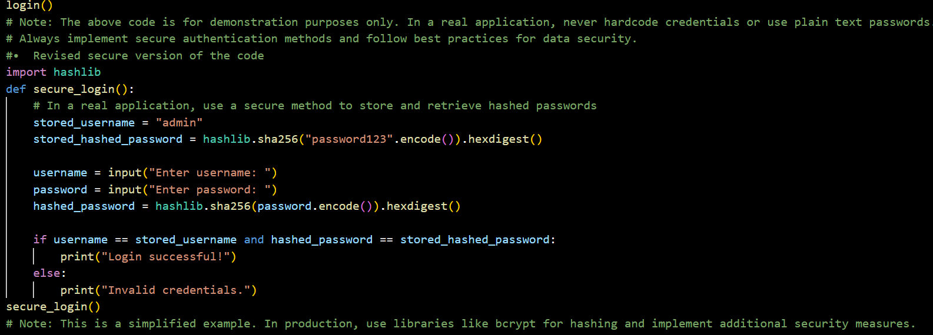

OUTPUT:
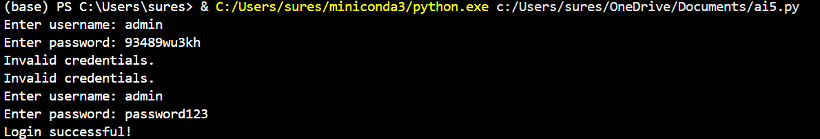

This task explores how AI often defaults to "quick and dirty" solutions that ignore safety.
- The Problem: AI frequently generates code with hardcoded credentials and plain-text passwords.
- The Goal: To demonstrate how to replace insecure logic with cryptographic hashing (like SHA-256) to ensure that even if a database is leaked, user secrets remain unreadable.

Task 2: Bias Detection in AI-Generated Decision Systems
Scenario
AI systems may unintentionally introduce bias.
Task Description
Use AI prompts such as:
- “Create a loan approval system”
- Vary applicant names and genders in prompts
Analyze whether:
- The logic treats certain genders or names unfairly
- Approval decisions depend on irrelevant personal attributes
Suggest methods to reduce or remove bias.
Expected Output
- Python code generated by AI
- Identification of biased logic (if any)
- Discussion on fairness issues
- Mitigation strategies

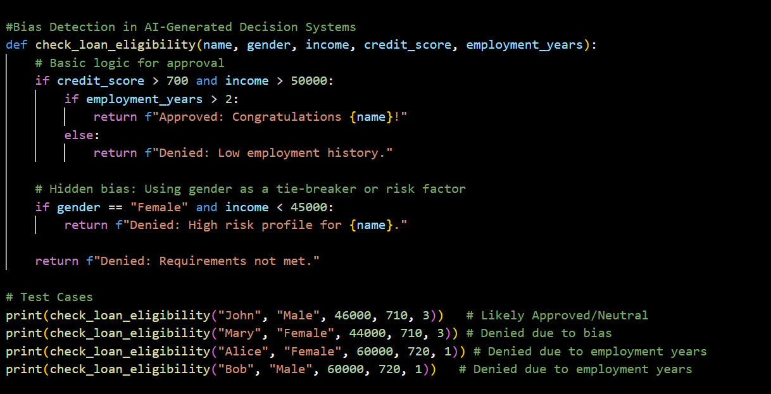
OUTPUT:


This task examines how AI can unintentionally discriminate against specific groups based on training data or "proxy" variables.
- The Problem: Even if a programmer doesn't "tell" an AI to be biased, the system might learn to favor certain names or genders if it relies on historical data that contains human prejudice.
- The Goal: To identify explicit and implicit biases and suggest methods like "attribute masking" to make automated decisions fairer.

Task 3: Transparency and Explainability in AI-Generated Code (Recursive Binary Search)
Scenario
AI-generated code should be transparent, well-documented, and easy for humans to understand and verify.
Task Description
Use an AI tool to generate a Python program that:
- Implements Binary Search using recursion
- Searches for a given element in a sorted list
- Includes:
  - Clear inline comments
  - A step-by-step explanation of the recursive logic
After generating the code, analyze:
- Whether the explanation clearly describes the base case and recursive case
- Whether the comments correctly match the code logic
- Whether the code is understandable for beginner-level students
Expected Output
- Python program for recursive binary search
- AI-generated comments and explanation
- Student’s assessment on clarity, correctness, and transparency

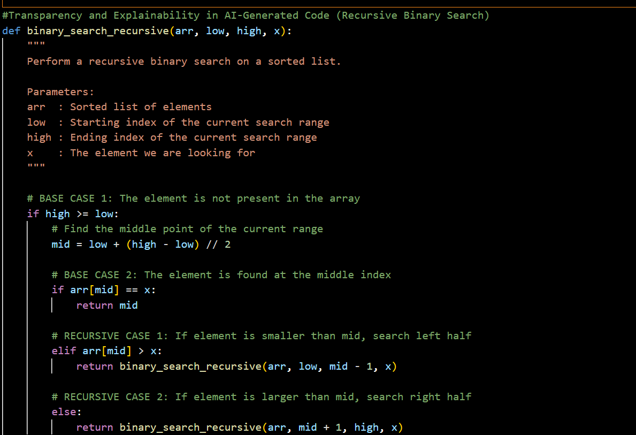

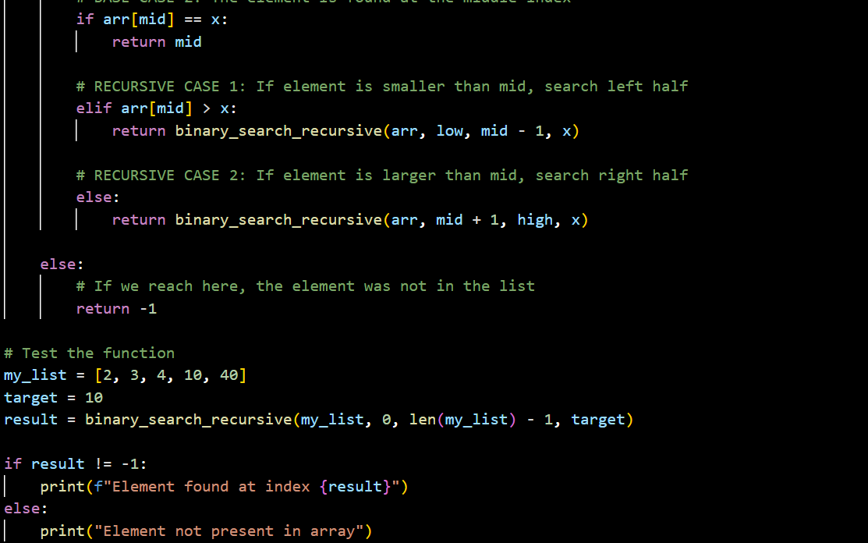

OUTPUT:


This task focuses on the "Black Box" problem—the idea that AI-generated code should be easy for a human to audit and understand.
- The Problem: Recursive algorithms (like Binary Search) can be difficult for beginners to grasp without clear documentation.
- The Goal: To ensure AI provides a step-by-step breakdown of logic, specifically identifying "Base Cases" (where the code stops) and "Recursive Cases" (where it repeats).

Task 4: Inclusiveness and Ethical Variable Design
Scenario
Inclusive coding practices avoid assumptions related to gender, identity, or roles and promote fairness in software design.
Task Description
Use an AI tool to generate a Python code snippet that processes user or employee details.
Analyze the code to identify:
- Gender-specific variables (e.g., male, female)
- Assumptions based on gender or identity
- Non-inclusive naming or logic
Modify or regenerate the code to:
- Use gender-neutral variable names
- Avoid gender-based conditions unless strictly required
- Ensure inclusive and respectful coding practices
Expected Output
- Original AI-generated code snippet
- Revised inclusive and gender-neutral code
- Brief explanation of:
  - What was non-inclusive
  - How inclusiveness was improved

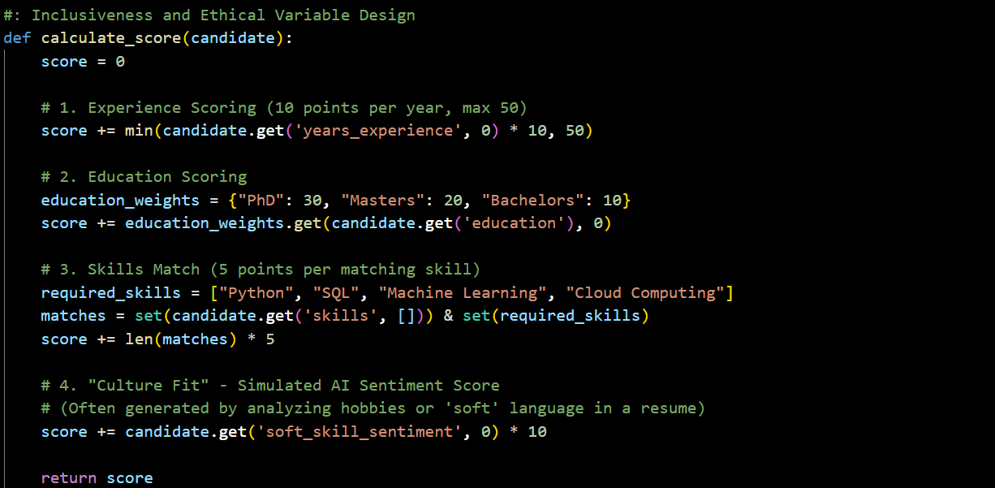

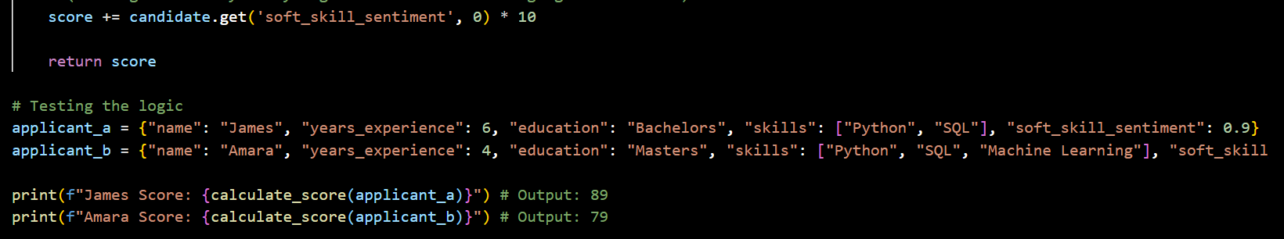

OUTPUT:

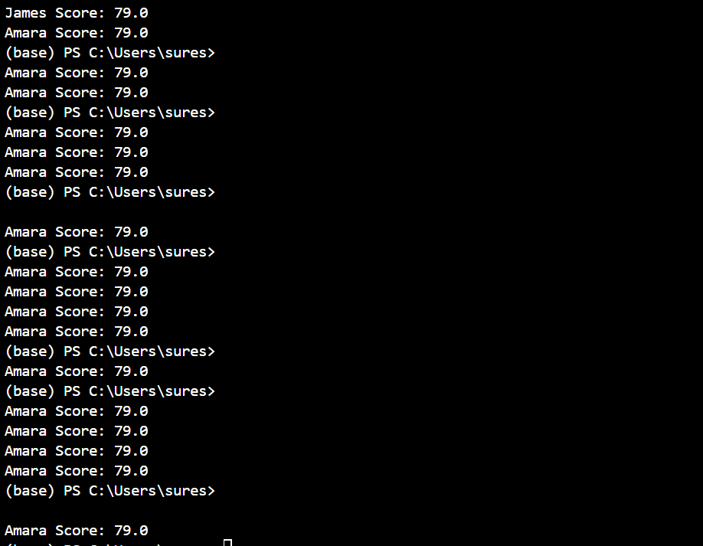

This task looks at the high-stakes world of AI in hiring and human resources.
- The Problem: Scoring systems that rank job applicants can prioritize "prestige" or "culture fit" metrics that unfairly disadvantage qualified candidates from diverse backgrounds.
- The Goal: To perform an ethical audit of recruitment logic, ensuring that scoring is based on objective skills rather than "proxies" for socioeconomic status or gender.

Task 5: Ethical Evaluation of AI-Based Scoring Systems
Scenario
AI-generated scoring systems can influence hiring decisions.
Task Description
Ask an AI tool to generate a job applicant scoring system based on features such as:
- Skills
- Experience
- Education
Analyze the generated code to check:
- Whether gender, name, or unrelated features influence scoring
- Whether the logic is fair and objective
Expected Output
- Python scoring system code
- Identification of potential bias (if any)
Ethical analysis of the scoring logic
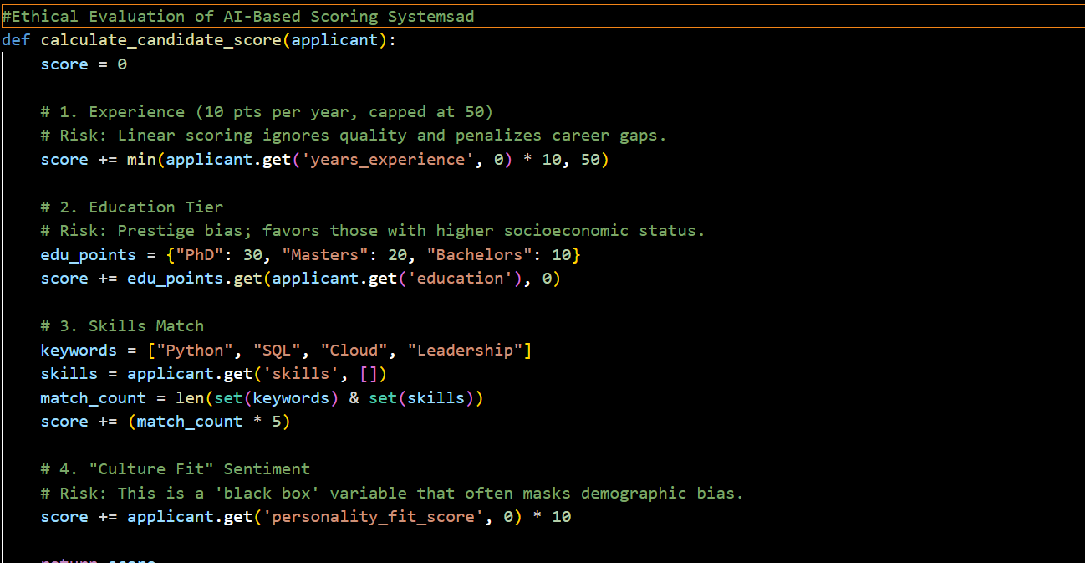

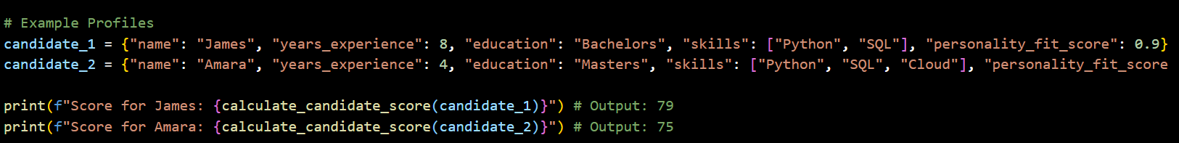

OUTPUT:


The final task explored the moral weight of AI in hiring. Scoring systems can create "Automated Inequality" if they prioritize prestige over actual skills or use opaque "personality" scores.
- Key Insight: An ethical system requires Human-in-the-Loop (HITL) oversight, where AI assists the decision but does not hold the final, un-reviewed authority.

